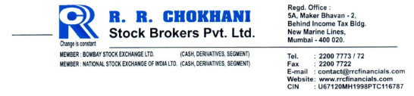

POLICY FOR CLIENT/ERROR CODE MODIFICATION
(Applicable for all exchanges/segment) Version 4.0

Background

R R Chokhani Stock Brokers Pvt Ltd is a member of BSE and NSE (SEBI Registration Number
INZ000253835). This policy has been issued in compliance with the requirements of:

1. SEBI Circular ref. CIR/DNPD/6/2011 dated 05-Jul-2011
2. SEBI Circular ref. CIR/MRD/DP/29/2014 dated 21-Oct-2014
3. BSE Notice No. 20110826-4 dated 26-Aug-2011
4. NSE Circular Ref. No. NSE/INVG/2011/670 dated 26-Aug-2011
5. Other circulars issued by BSE and NSE from time to time

Policy

1. All orders will be placed in the trading system in the Unique Client Code of the client
2. Only genuine punching errors in client codes while placing orders shall be allowed to be modified.
3. While carrying out code modification, genuineness of the punching errors shall be
verified against corroborative circumstantial evidences like similarities of codes/ names, trades in immediately preceding codes, square off trades without holdings or position or any such other evidences.
4. Client code modification shall be carried out only after prior permission from one of the Directors
5. All such Genuine Error code modification shall be carried out through UCC registered
‘ERROR’ account. Any rate difference including transactions costs shall be accounted for. Due reason will be recorded in the exchange system appropriately.

6. In case of any code changes directly from client code to client code bypassing the ERROR code, the same shall be informed to the exchange with the appropriate reason code, being
a. Error due to miscommunication – similar codes/ similar name
b. Transfer between relatives
7. The Penalties, if any charged by the Exchange/any regulatory authorities shall be passed on to the concerned client/Authorised Person if the reason of the error is attributable to any negligence on their part else shall be borne by BCB Brokerage Private Limited
8. Wherever applicable, waiver for penalty shall be requested as per SEBI Circular ref.
CIR/MRD/DP/29/2014 dated 21-Oct-2014

Sd/-
Ramakant Chokhani
Director DIN 00613176
R R Chokhani Stock Brokers Pvt Ltd

The above revised policy was approved by R R Chokhani Stock Brokers Pvt Ltd at the Board meeting held on 01-April-2024.

